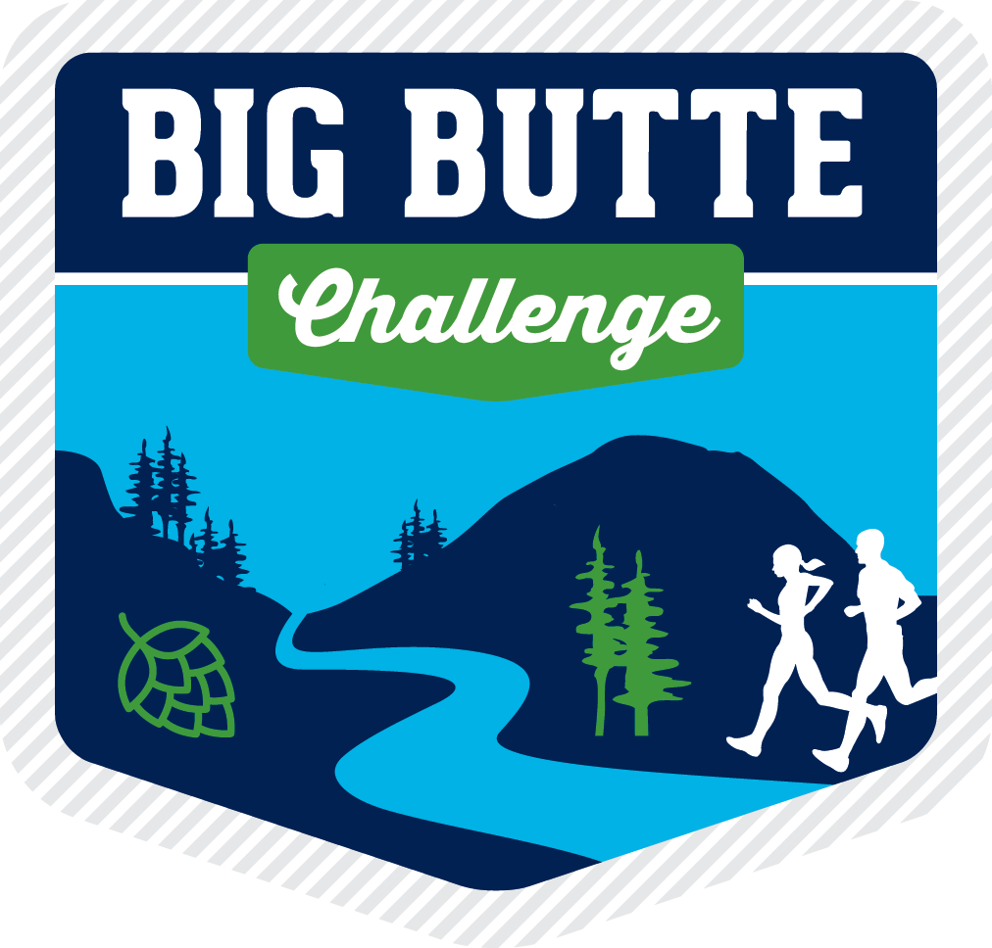

2024 Big Butte Challenge: Memorial Day Weekend- October 1st
Join us for the Big Butte Challenge, where families and individuals come together to explore eight butte-iful buttes & breweries across Central Oregon, at their own pace, between Memorial Day and Labor Day Weekend. Once registered, participants receive a swag bag with a beer token for each butte-sponsored brewery, custom Big Butte swag, and other surprise goodies from our sponsors. Participants will hike or run each butte on their own schedule, with prizes awarded for the first to summit all buttes, best photos, and more!

Partnership Opportunities
This family-friendly event is all about highlighting the amazing craft breweries & businesses of Central Oregon and we’re excited to offer an opportunity for you to highlight your brand, share your product, or help draw business to your establishment throughout the summer. Last year was a huge success, and we expect to have 600-750 participants in 2024.

Provide a perk
Draw business to your awesome company by providing a perk to our participants. Once registered, attendees are able to unlock and redeem various perks through the website, which last year resulted in a 30% retail activation for our partners! Some Examples include a free appetizer or food item at a local restaurant, store discount, promo code for online purchases, free bike rental or fitness class, etc.
Add to The Swag Bag
Spread the word about your awesome product by contributing to our awesome swag bags! These will be picked up by participants at registration and can include coupons, gift cards, product samples, or company swag. While we expect to have 600-750 participants this year, the amount you provide is up to you.
Host your own photo contest
This is an opportunity to get creative and further your engagement with our participants! Some examples are “best post-butte brewery photo”, best costume at the sponsored butte, best adventure photo featuring your beer, etc.

We will market all contests on our website and social media, though please note that it’s up to each business to manage submissions (likely via social media), select winners and provide prizes.

Sponsor a Butte
Breweries / Businesses commit to providing each participant with a pint (or other tasty treat) at the completion of their summit, which they redeem using a custom token provided at registration. Once they’ve reached the summit of a particular butte they are also prompted to enter a photo contest by tagging you on social media.

Given that this event enables people to spread the challenge out at their own pace, no more than a couple of participants will be hiking the same butte (and going to the sponsored location) on the same day, so the extra business coming in will be spread out over the duration of the event.

Butte Sponsors also commit to providing Cascade Relays 5 “prize bags”, which we allocate to contest winners at the completion of the Big Butte Challenge. The contents are up to each business and typically include swag, a gift card, drinkware, etc.

